**Tomb of the Mask: Title Screen**(Screen dimensions are 1920x1080)

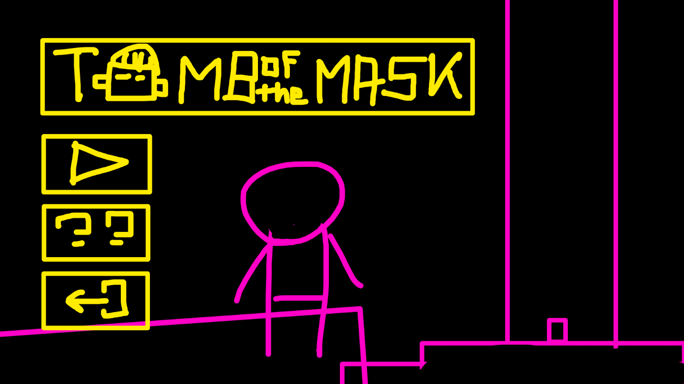  
The buttons are placed vertically, and the title is displayed on the side. This share similarities with the emulated version.



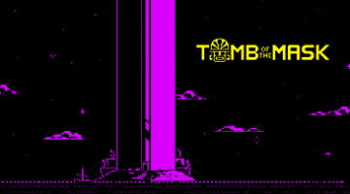  
**Emulated version**

**Buttons**

* **PLAY:** Let you start the game.
* **??:** Shows the HELP SCREEN.
* **Quit:** Close the game.

**Help Screen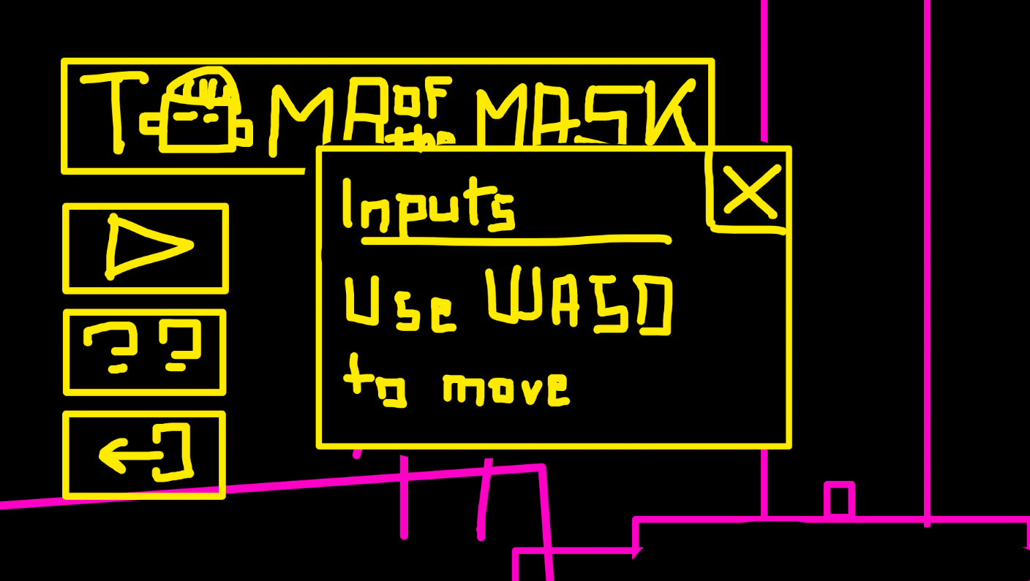 The text is a placeholder.**

